Week 05

**Task 1. Create Web Pages in OpenWRT**

Picture showing webserver page in openWRT linux server, after visiting page 12214103.html

The same page with the click here! button is being clicked

Task 2. **Capture HTTP Packets**

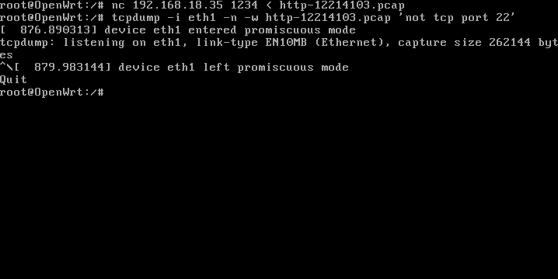

Image showing tcpdump command being used to capture packets

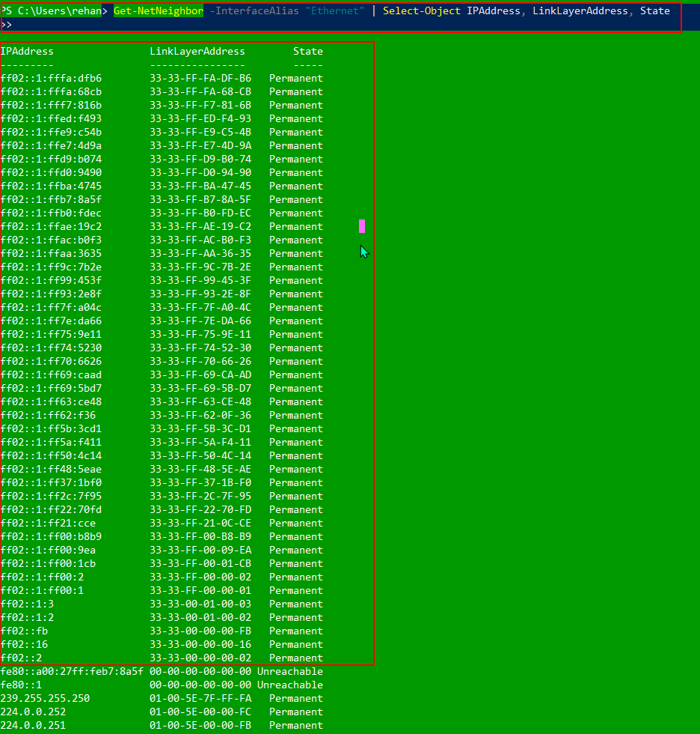

BEFORE Pinging : Image of ARP table showing of my primary physical interface

Communicate with other devices on your LAN (e.g. ping other computers )

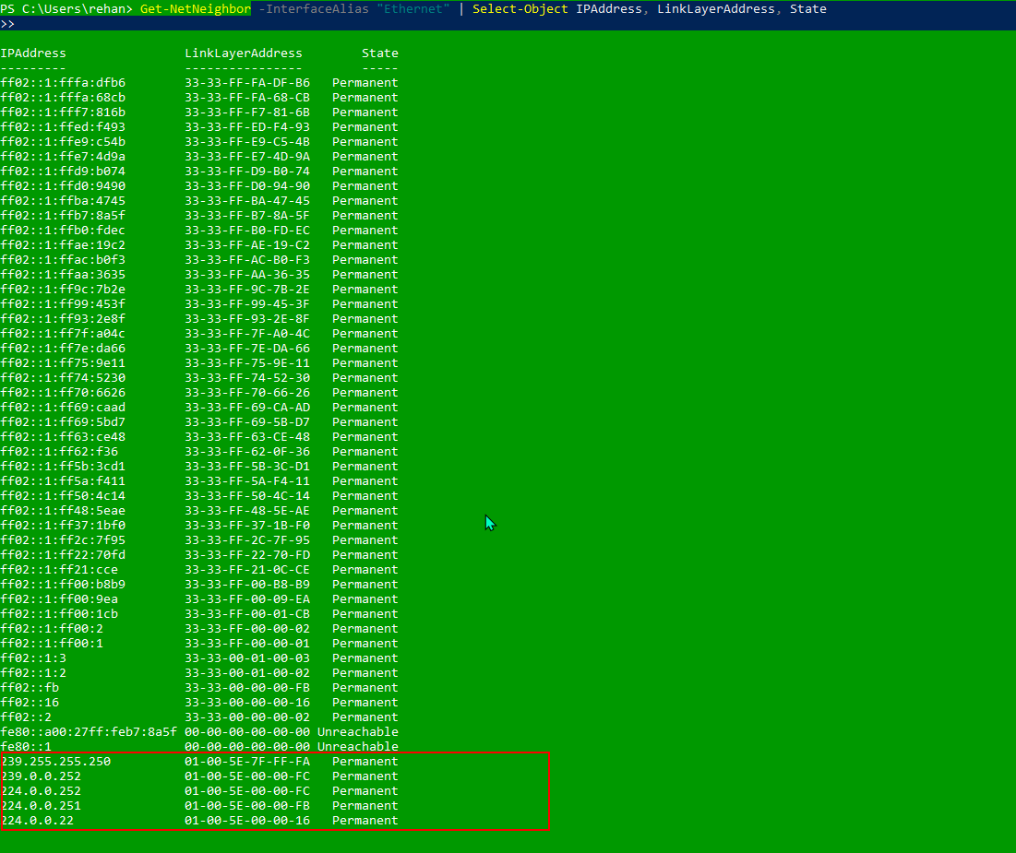

AFTER Pinging : Image of ARP table showing of my primary physical interface

**Task 3. Analyse HTTP Packet Capture**

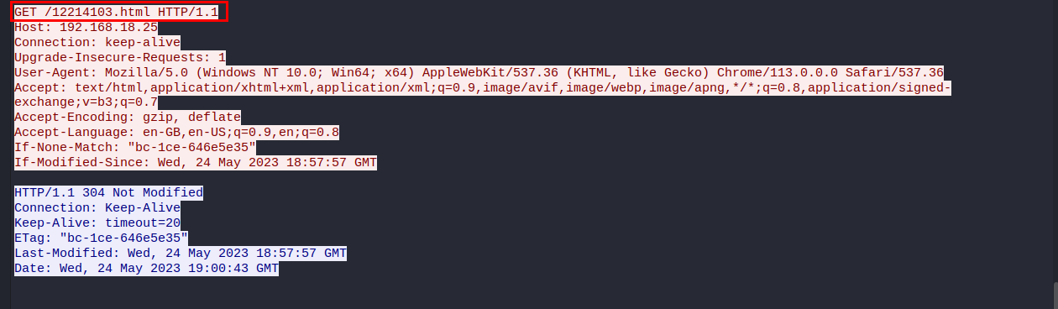

**What requested:** /12214103.html page was requested.

**What responsed:** The 12214103.html page was parsed

**The URL entered:** http://192.168.18.25/12214103.html.

Host: 192.168.18.25

Transfer Protocol: HTTP

User-Agent: Mozilla/5.0 (X11; Linux x86_64; rv:102.0) Gecko/20100101 Firefox/102.0

Accept-Language: en-US,en;q=0.5

Accept:text/html,application/xhtml+xml,application/xml;q=0.9,image/avif,image/webp,*/*;q=0.8

When the button to display the date and time is clicked, the browser does not send a request to the web server. This is because the client-side JavaScript code is responsible for showing the date and time and it runs within the browser itself. The HTML file, along with any associated CSS and JavaScript files, is initially loaded from either the local filesystem or the web server. Once the page is loaded, any interactions or actions performed on the page, such as clicking the button, are handled locally by the browser and do not require additional requests to the server. The JavaScript function executes within the browser, dynamically updating the displayed date and time in the HTML page without the need for communication with the web server.

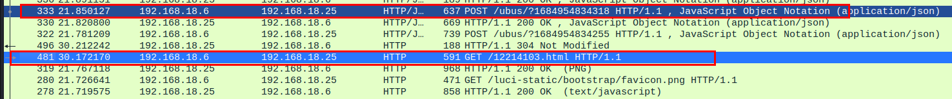

The referrer refers to an HTTP header field transmitted from the user's web browser to the web server during a request, indicating the URL of the webpage that directed the user to the current page.

1. Web servers can make use of the referrer information in different ways:
2. Traffic analysis: By examining the referrer data, web servers can obtain insights into the origins of their website's traffic. This enables them to identify the websites, search engines, or social media platforms that are responsible for driving visitors to their pages.
3. Marketing and advertising: Referrer information facilitates the tracking of marketing campaigns and advertising endeavors. It allows website owners to assess the effectiveness of referral sources in terms of generating traffic or conversions, empowering them to optimize their marketing strategies accordingly.
4. Personalized content: Referrer information can be employed to customize the content presented to users. For example, a website can offer personalized recommendations or display related content based on the referrer URL.
5. Security and access control: Referrer data serves as an additional security measure. Web servers can validate the referrer to safeguard against unauthorized access and implement measures to counter cross-site request forgery (CSRF) attacks.
6. Analytics and statistics: By aggregating and analyzing referrer information, valuable website analytics and statistics can be generated. This data aids website owners in comprehending user behavior, understanding traffic patterns, and optimizing the overall performance of their website.

The HTTP protocol version in use is 1.1, and the communication protocol being utilized is TCP.

The TCP connection is established between packets 4 and 6 according to the attached image, and the time taken to establish the connection is typically a few seconds, usually between 1 and 2 seconds.

The acknowledgement can be shown below:



**Task 4. View Your Cookies**

**Cookies:**Cookies have the capacity to store various types of information about you and your browser. While the specific contents of cookies can differ, some common types of information they may contain are:

**Session identifiers:** These identifiers or tokens are used to maintain your session on a website, allowing the website to recognize you as the same user across different pages.

**Preferences and settings:** Cookies can store your preferences and settings for a website, such as language preferences or customized layouts, providing you with a personalized experience.

**Authentication information:** When you log into a website, cookies may store authentication details like your username or encrypted tokens to remember your login state and authenticate you during subsequent visits.

**Tracking information:** Cookies can include tracking data used by third-party services for analytics, advertising, or user behavior tracking, enabling personalized advertisements and gathering usage statistics.

**Shopping cart data:** In e-commerce websites, cookies can store information about items in your shopping cart, ensuring that your selections are remembered as you browse through the site.

**Referral URLs:** Cookies can retain the URL of the website that referred you, which can be used for analytics or tracking the effectiveness of marketing campaigns.

It is important to note that cookies typically store data in an encoded or encrypted format to protect privacy. Websites should follow privacy policies and regulations to handle and protect personal data obtained through cookies appropriately.

